How to Document SCCM/MECM/MDT Task Sequences

Since I work for a global IT company, I am often brought into a client environment to design, remediate or improve upon their current Windows 10 imaging and deployment process.

I analyze everything related to imaging and deploying Windows 10, including the task sequence.

Figuring out the logic of a task sequence you didn't develop is a challenge because you are constantly switching between the Properties tab and the Options tab to see if the group/step has any restrictions. It also requires physical access to the SCCM/MECM/MDT console so you can view the task sequence.

During the assessment phase, I usually only go onsite to the client for a day or two. This created challenges for me because when I'm onsite, I just gather data, and then once back in my office I analyze it.

With all the OS deployment consulting engagements I perform, I needed a tool that accurately documented MDT/SCCM/MECM task sequences. Since there is nothing built in to MDT/SCCM/MECM, and there was nothing on the internet that was accurate, I wound up developing my own tool. During Microsoft Ignite 2016 I made the tool available to the IT community.

You can access the tool by clicking on the Task Sequence Documenter link in the menu, or by going to the following URL

<https://www.scottjfairchild.com/task-sequence-documenter>

If you are unsure how to export just the task sequence XML, I have provided instructions on the [Help](https://www.scottjfairchild.com/help) page.

As you can see from the below screen shot, every step is listed along with any conditions the group/step may have. This makes it much easier to understand, troubleshoot and improve task sequences

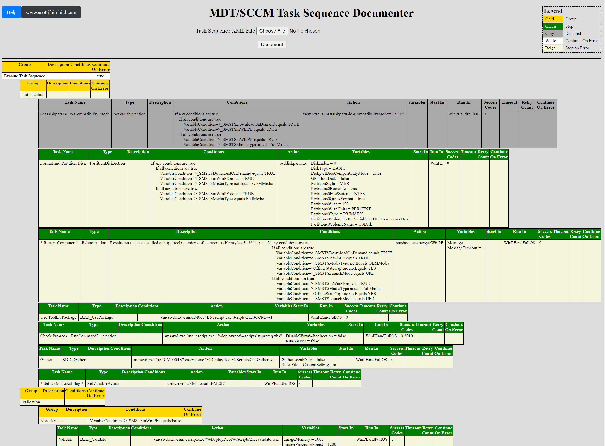

Often times, after creating an MDT or SCCM task sequence, you need to document it for yourself or your customers. Usually, this involves creating a table with the groups and steps, extracting their descriptions, identifying conditions and denoting the step actions and variables and then having format it all nicely and with indents denoting hierarchy. All of this information is usually already in the XML of the task sequence and all you're really doing is formatting. You can automatically format XML documents by using an XSL transform with the right logic. In order to do this:

# How to get the ConfigMgr/SCCM/MDT Task Sequence XML file

### **ConfigMgr/SCCM**

If you open a PowerShell window from within the SCCM console, run the following command

(Get-CMTaskSequence | Where-Object {$_.Name -eq "<TaskSequenceName>"}).Sequence | Out-File <Path>\ts.xml

**Note:** Make sure you replace <TaskSequenceName> and <Path> before running the command

If you open a PowerShell window from a server/desktop where the SCCM console is installed, run the following commands

$CMfolder = split-path $env:SMS_ADMIN_UI_PATH  
Import-Module $CMfolder\ConfigurationManager.psd1  
set-location <SiteName>:  
(Get-CMTaskSequence | Where-Object {$_.Name -eq "<TaskSequenceName>"}).Sequence | Out-File <Path>\ts.xml

**Note:** Make sure you replace <SiteName>, <TaskSequenceName> and <Path> before running the commands

### **MDT**

The ts.xml file is located in the %DeployRoot%\Control\<TaskSequenceID>\ directory.

## **How to save the output**

You need to use Firefox or Chrome to save the output (Right click, Save as... or Save Page As...)

1. Copy the attached file at the bottom of the post to the same folder as your task sequence.

2. Open your task sequence in your favourite text editor.

3. After the first line which should look something like this:

<?xml version="1.0"?> or <?xml version="1.0" encoding="utf-8"?>

enter the following as the second line:

<?xml-stylesheet type="text/xsl" href="tsDocumentorv1.xsl"?>

4. Save your task sequence file and open it in Internet Explorer. Presto! The XSL takes care of formatting, indents and sizing.

Your Task Sequence should look like this:

[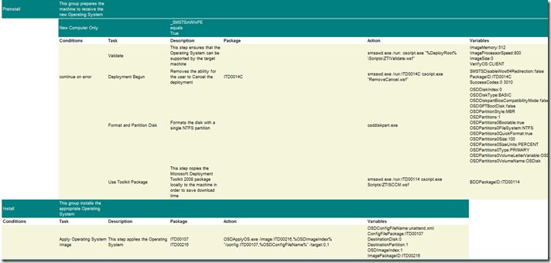](https://web.archive.org/web/20150407184905/http:/blogs.technet.com/blogfiles/deploymentguys/WindowsLiveWriter/DocumentingyourTaskSequencesAutomagicall_162E/image_2.png)

You can even change the styles of groups and steps easily.

1. Open up the tsDocumentorv1.xsl file

2. Edit the following section:

<STYLE TYPE="text/css">  
  TD.group { background-color:teal;color:white }  
  TD.step { background-color:beige }  
</STYLE>

Change the colours or any other css properties you choose!

The XSL should work with task sequences created with BDD 2007, MDT 2008 and SCCM 2007.

Please try it out and post comments.